**Web Designing**

**MODULE: 5 (JQuery Basic, Effects & Advance)**

**Q1. What is JQuery?**

**A1.** JQuery is a lightweight, "write less, do more", **JavaScript library**. The purpose of JQuery is to make it much easier to use JavaScript on your website.

JQuery takes a lot of common tasks that require many lines of JavaScript code to accomplish and wraps them into methods that you can call with a single line of code.

JQuery also simplifies many complicated things from JavaScript, like AJAX calls and DOM manipulation.

The JQuery library contains the following features:

* HTML/DOM manipulation
* CSS manipulation
* HTML event methods
* Effects and animations
* AJAX
* Utilities

**Q2. How to apply CSS using JQuery, how to add classes and remove classes in JQuery, and JQuery animation?**

**A2.** To apply CSS using JQuery, you can use the **css()** method. You can use the **addClass()** and **removeClass()** methods to add or remove classes. For animations, JOuery provides several methods like **animate()** for custom animations and **fadeIn()**, **fadeOut()**, **slideUp()**, **slideDown()**, etc., for predefined effects.

1. **Applying CSS:**

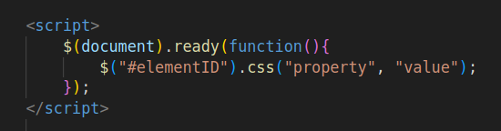

1. **Adding & Removing Classes:**

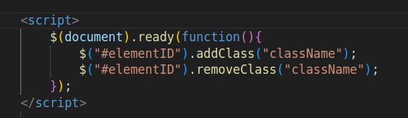

1. **JQuery Animation:**

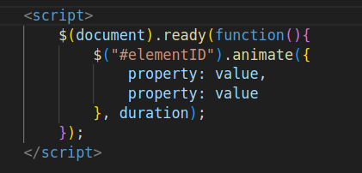

**Q3. How to create a slider with animation?**

**A3. ￼**